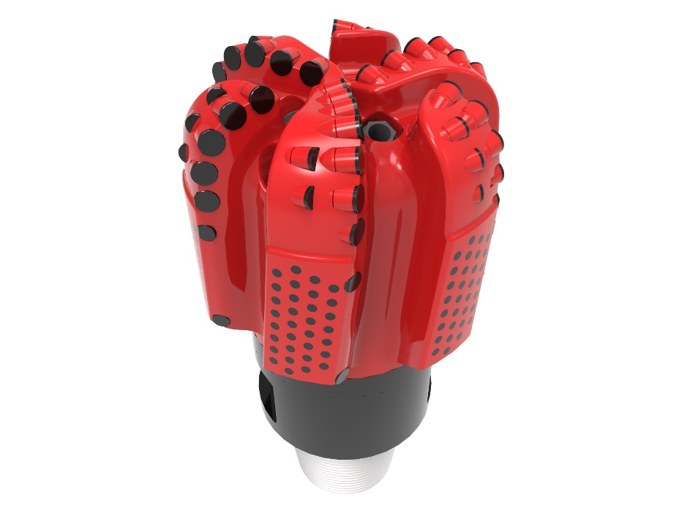
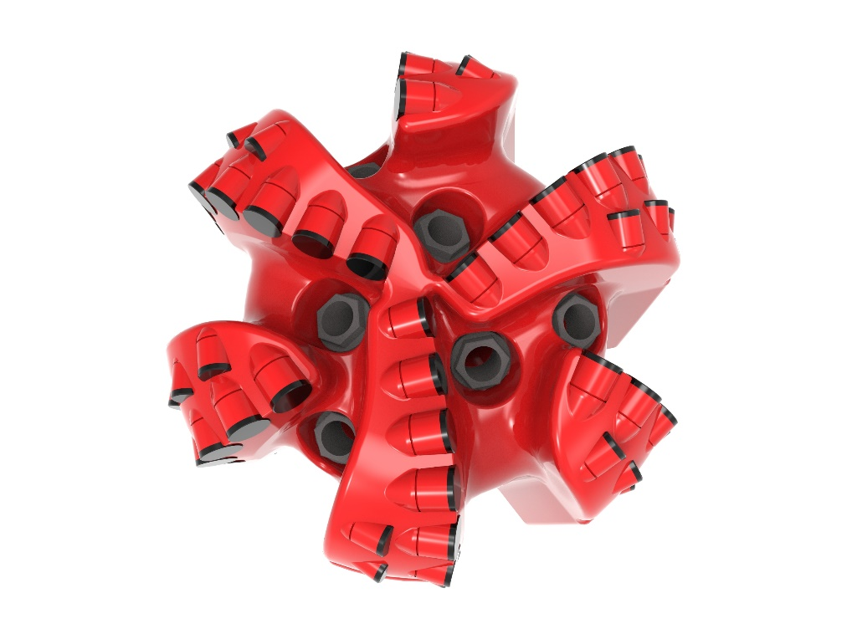

Drill Bit Specifications:
Cutter Size (Primary, Sec) | 5/8”, 1/2”
Cutter Count (Total, Gage, Back Ream) | 63, 12, 6
Blade Count | 6
Gage Length (Inches) | 4.00
Nozzle Count (Primary, Sec.) | 6
Nozzle Series (Primary, Sec.) | 60
JSA (Sq. Inches) | 13.08
Max. TFA (Sq. Inches) | 2.23
Operating Parameters:
Max. Weight on Bit (1,000 Lbs.) | 60
Make-up Torque (ft/lbs) | 16,488
Nominal Dimensions:
Overall Length (Inches) | 16.27
Make Up Length (Inches) | 12.15
Bit Breaker | SKB-21010
Connection | Ø4-1/2" API Reg.
Approx. Weight (Lbs.) | 160

Tailor-Made Features:

- Premium grade cutters maximize ROP and Life
- Nozzle configuration and large open face volume optimize blade cleaning and cuttings removal

616M-XR(BR) Nomenclature Explained:

• | 6 | = | Number of Blades
• | 16 | = | Primary Cutter Size (16mm)
• | M | = | Matrix Bit Body
• | XR | = | Double Row of Cutters
• | BR+ | = | Back Reaming Cutters


